Problem 1: Describe the course evaluation scores. Calculate some summary statistics and display the data using a histogram (with proper colors, labels, titles, etc.)
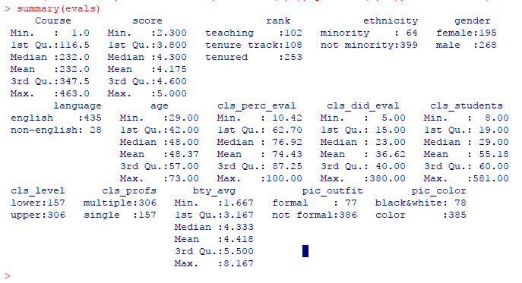
colors <- c("red", "yellow", "green", "violet", "orange","blue", "pink", "cyan", "red", "yellow", "green", "violet", "orange","blue", "pink")
hist(evals$score,main="Hstogram of Course Evaluation Score", xlab = "Score", xlim = c(0,5), ylim = c(0,80), col = colors)

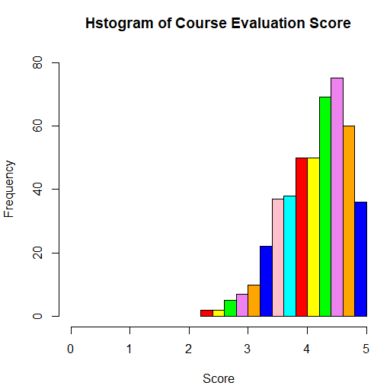
(0-1) Very Unsatisfactory, (1-2) Unsatisfactory, (2-3) Satisfactory, (3-4) Good, (4-5) Excellent
The above given histogram shows that no professor is evaluated and below satisfactory score. About 60% of score evaluation scores are in excellent zone. That means the professors are best in their field, technique of teaching and fulfill students expectations.
Problem 2: Visualize the relationship between course evaluation scores and the “beauty” of the professor using a scatterplot. Make the graph “pretty” by changing the type of point, the xlim to be 1-5 and ylim to be 0-10, the colors, the axis labels, and the title of the graph. Does there appear to be an association?
plot(score, bty_avg, main= "Scatterplot of Course Evaluation Score vs. Avg. Beauty of the Professor", xlab="Course Evaluation Score", ylab="Avg. Beauty of the Professor", xlim = c(0,5), ylim = c(0,10), pch = 20, col = "pink")

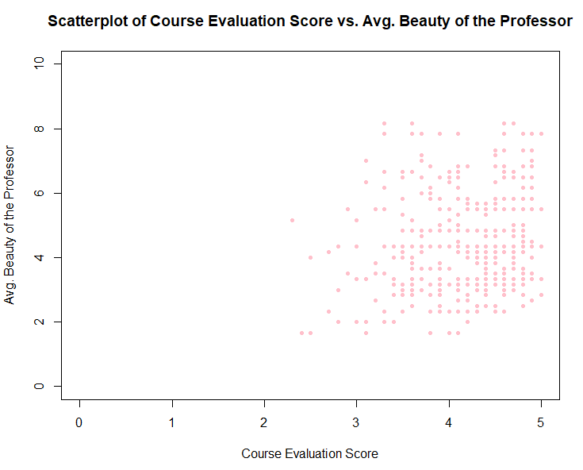
If we observe the scatterplot in particular region, there is saturation at 3.5-5 (x-coordinate) and 3-5 (y-cordinate). But as we go up from here along with y-axis the saturation starts decreasing very slowly.
Hence, we can say that course evaluation scores are not influenced by the beauty of the professor.
Problem 3: Describe the relationship between course evaluation scores and gender of the professor by creating a side-by-side boxplot. Also visualize the distributions of course evaluation scores by gender using two histograms in the same graphics window. For both the histograms and boxplot, change the color and titles of the graphs. Do males or females get higher course evaluations, on average? Is it a statistically significant difference?

From below shown box plot we can say that professors with gender male have higher average course evaluation score than female professors.
par(mfrow = c(1,1))
boxplot(evals$score~evals$gender, col = rainbow(2), main = "Boxplot of Course Evaluation Scores by Gender")
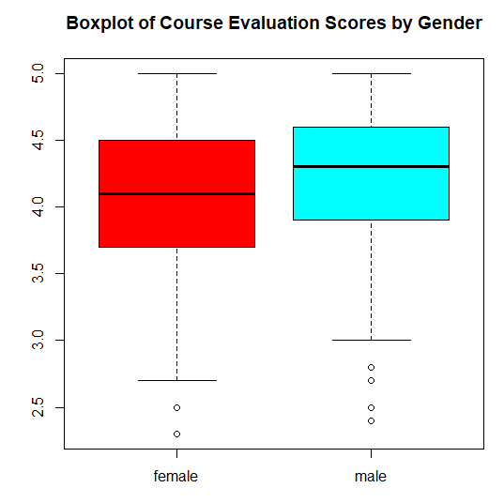

par(mfrow = c(1,2))
hist(evals$score[evals$gender=="female"], main = "Course Evaluation Scores by Female", xlab = "Score", col = rainbow(6))
hist(evals$score[evals$gender=="male"], main = "Course Evaluation Scores by Male", xlab = "Score", col = rainbow(13))

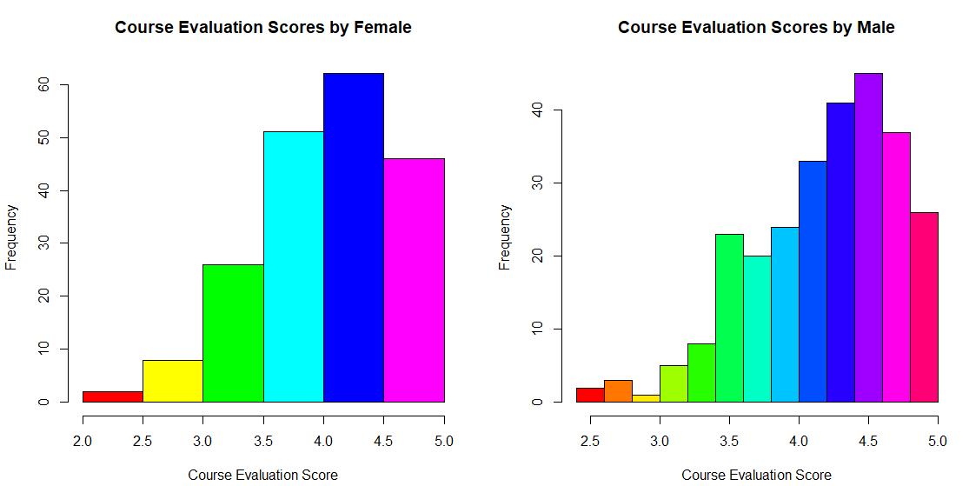

Problem 4: Describe the gender of professors using a table and a bar plot. Make sure the table and plot are properly labeled and titled!
gender.table <- matrix(c(195, 268),nrow=2,ncol=1)
colnames(gender.table) <- c( "No. of Professor's")
rownames(gender.table) <- c( "Female", "Male")
gender.table
gender.count <- margin.table(gender.table,1)
barplot(gender.count, main= "Bar plot - Gender of Professors", col= c("yellow", "green"), ylab="Count")
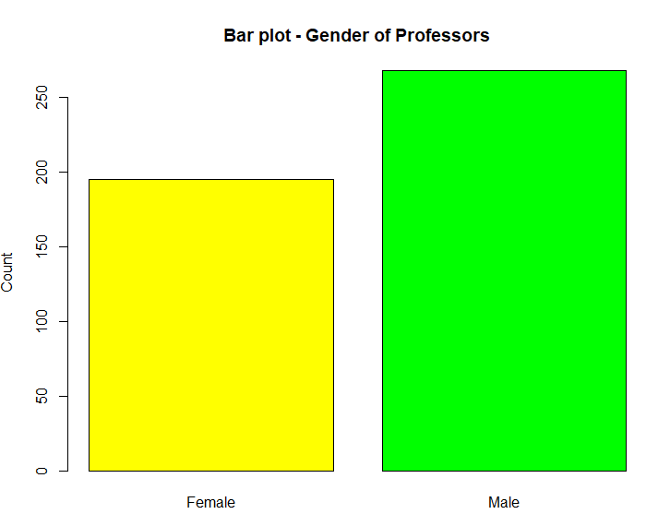
Problem 5: Describe the relationship between rank of the professor and the level of the course by generating a two-way table and a clustered bar plot. Add a title to the clustered bar plot. Add a legend to the plot describing the bar colors of each group.
t1 <- table(rank, cls_level)
t1
par(mfrow=c(2,2))
barplot(t1, legend.text=rownames(t1), main = "Level of Course vs. Rank of Professor")
barplot(t(t1), legend.text=colnames(t1))
barplot(t(t1), beside=T, legend.text=colnames(t1))
barplot(prop.table(t(t1),2),beside=T, legend.text=colnames(t1))
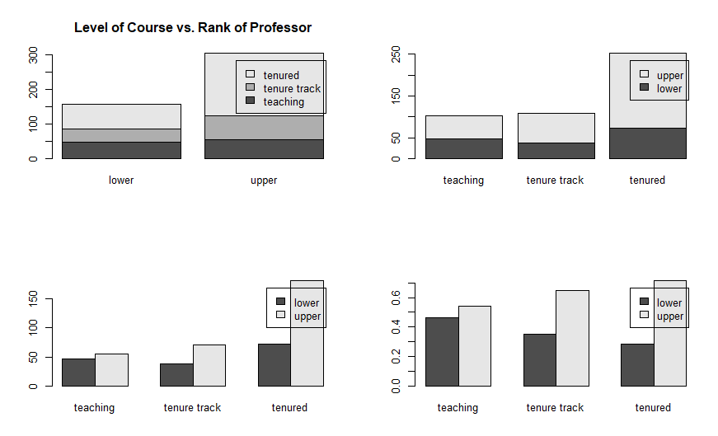

The above clustered bar plot shows that the most experienced professor (tenured) teaches maximum of upper level of courses, while the least experienced or in probation period faculty teaches more of the lower level of courses.

